Updates MER Analysis: (All this data is for patient 2018_03 – Ipsilateral)
- Since I lost access to the workstation after graduating, I focused on optimizing the code to allow me to analyze more data with limited memory. Results after optimization (no bootstrapping):
- With this optimization/reorganization I was able to capture about 4 times as many action potentials (or peaks since some I believe are not APs). Below are plots I used to choose which APs to use in further analysis.
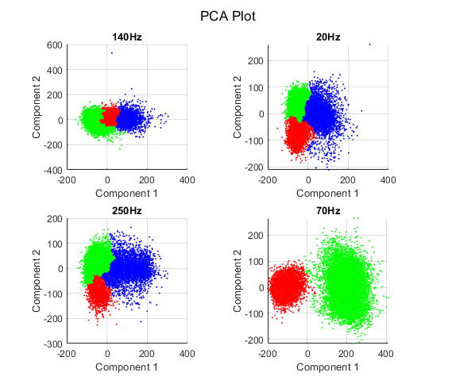
3. I chose to use neurons:
block(1).neurons = [1,2,3]; % Block 1 = 140Hz
block(2).neurons = [1,3]; % Block 2 = 20Hz
block(3).neurons = [1,3]; % Block 3 = 250Hz
block(4).neurons = [2]; % Block 4 = 70Hz

4. Results of specifying these neurons (no bootstrapping):

5. I have also tried applying bootstrapping when using ALL available action potentals (peaks), however, this due to the large number of APs in each group there were large variations between trials. There was also no apparent difference between stimulation ON/OFF. It should be noted that the APcount vs LFP RMS plots showed much less dependence (maybe bootstrapping is not necessary?)

